# Game Design Document for *Cardgame*

## Overview

*Cardgame* is a 1 on 1 card game set during a war between neighbouring kingdoms. There is an emphasis on the financial management aspect of war. Players take decks of their own making head-to-head against each other, made up of 3 types of card: Units, Utilities and a single Lord per deck. Units are creatures that stay on the battlefield and can enter combat with the opponent’s units, or raid the opponent’s gold supply should their battlefield be empty. Utilities are one time abilities with powerful effects, ranging from drawing extra cards, to gaining gold, to killing an opponent's unit. Each player also plays as a Lord, which is a powerful card with a unique ability that supports different strategies, however the Lord cannot attack units. The Lords’ abilities will help you win the game through amassing gold, maintaining/gaining card advantage, etc. Building your deck to synergize with your Lord's ability is a key aspect to winning the game.

The card game is a fast paced one, closer to *Yu-Gi-Oh!* than *Hearthstone* or *Magic: The Gathering*, to reflect the hectic nature of war. Players use Gold to do everything, including hiring units, using utilities, using unit abilities, and paying their unit’s wages. If a player runs out of gold they go bankrupt. They are unable to pay their units wages and as a result they begin to revolt and that player will lose the war should they not recover. As a result, gold management is a key feature of the game.

## Players

*Cardgame* is a game for two players who go head-to-head with decks that they’ve created. Each card in the deck represents either a unit in their army (for example, a plague doctor) or a utility that they can use to get ahead (for example, a bank withdrawal). The exception to this is the Lord.

Each player can select one of a number of Lord’s, which acts as not only their character with a unique ability, but also as their avatar. This would be similar to the class a player selects in *Hearthstone*, or their Commander in the Commander format of *Magic: The Gathering* (however without the limitation to deck-building present in both of these cases).

Players play together over a network on two separate machines, however the game is designed in such a way that it would be easily replicable in real life with physical cards. To specify, in-game the player can only do with the cards what they are able to do with a card in real life, for example, change its orientation, flip it over, or put counters on it.

Players also control Units. A unit that is hired by the player can be ordered to attack other units, the opponent’s Lord, and also use its own ability (should it have one). Within the context of the game this is the player (The Lord) giving orders, as opposed to playing as the Unit itself.

## Story

*Cardgame* does not have an in-depth story – the primary focus is on gameplay and having a too in-depth lore can, in my opinion, limit card design. However, as a Lord story, the Players play as Lords, who are the leaders of various neighbouring kingdoms and clans fighting over a barren land they all wish to claim to expand their own territory. Each Lord commands an army consisting of hired units, and making use of hired services known as utilities. The victor of a match would be the ruler who claims this barren land.

## Look & Feel

During battle, the player’s perspective in *Cardgame* is a fixed-perspective, top-down view of an initially empty battlefield, which is populated with cards as the game progresses. Cards and any counters the game needs are represented by 2D sprites. The player’s side of the field is on the bottom half of the field, while the opponent’s field is rotated onto the opposite side. Cards are always displayed upright for each player so they can read any cards in play. Cards in the opponent’s hand cannot be viewed. For more detail on the orientation of the playing field see the Interface section.

The feel is an extension goal – functionality is more important.

The feel is that of a brutal battlefield – cards are destroyed, burnt, etc. Combat is accompanied by the sounds of clashing swords, and dying units will roar in pain, all accompanied by the sound of war drums. Actions should feel impactful, and so will be accompanied with appropriate visual and sound effects. Card artwork should have a consistent medium, but the theme should differ depending on the kind of card it is. For example, some cards may depict creatures such as frogs, yet others may depict rotting zombies. The latter would be a darker themed card, however drawn in a similar style, as opposed to the former which may be a bit more colourful.

## Tokens

The following is a list of tokens in *Cardgame:*

* Cards (see *Cards.xlsx* or *Cards.csv* for specific details on each card) (in game and in deck-builder):
  + Units
  + Utilities
  + Lords
* Gold
* Card Cost
* Card Health
* Card Strength
* Poison Counters
* Decks (in-game and in deck-builder)
* Battlefields
* Hands
* Discard piles
* Players
* Dice
* Card backs (back side of card)
* Debt counters
* Multiplayer score (based on wins and losses)

## Rules

The following are a list of the rules that make up *Cardgame*:

**[R1]** Each player starts the game with 25 gold.

**[R2]** When a player starts their turn with 0 gold, they gain 15 gold and one debt counter.

**[R3]** If a player starts their turn with 0 gold and with a debt counter, they lose the game.

**[R4]** Each player’s deck must be exactly 25 cards, PLUS one Lord

**[R5]** Each player starts the game with their Lord outside of the deck, to the left of their hand/field.

**[R6]** Every card has a cost in gold to put it into play. Units also have health and strength.

**[R7]** When played, Units will stay on the field however Utilities will go to the Discard pile once their effect has been resolved.

**[R8]** Units are killed either when their health reaches 0 or when killed by card effect. Killed cards go to the Discard pile unless specified otherwise.

**[R9]** Card effects overrule game rules

**[R10]** The turn player can enter combat with each of their Units once per turn

**[R11]** When entering combat, the attacking player selects an opponent’s unit as a target. Both units then lose health equal to the other’s strength.

**[R12]** If the opponent has no units on the field the turn player can “raid” the opponent’s supplies instead. If they do, the opponent loses gold equal to half the strength of the attacking unit.

**[R13]** A unit with a poison counter loses 1 health at the end of each turn per counter.

**[R14]** Each player gains 5 gold at the beginning of every one of their turns (after checking whether they need a debt counter) EXCEPT on their first turn.

**[R15]** Each player draws a card at the beginning of their turn.

**[R16]** The player who goes first cannot attack during their first turn.

**[R17]** Units can be “buried” through the effects of certain cards (including themselves!). Buried cards are be flipped face-down.

**[R18]** Buried cards cannot attack, be attacked or use their effects.

**[R19]** Cards cannot effect buried cards with their effects unless they specify that they effect a buried card(s).

**[R20]** Some cards can “bounce” themselves or other cards using effects. This means to return the card to its owner’s hand.

**[R21]** At the beginning of each player’s turn (after checking for debt) they must pay their unit’s wages (1 gold per unit).

**[R22]** Anything that occurs at the beginning of a player’s turn (checking for debt counters, effects, etc) happens *before* that player draws.

**[R23]** Any card effects that happen at the end of a player’s turn happens immediately before the start of the next player’s turn. This means the turn player cannot do anything (hire units, use utilities, etc) after these effects go off until the beginning of their turn.

**[R24]** Should multiple effects trigger simultaneously, the turn player gets priority on their effects. They may choose any ONE effect that has triggered, resolve it, then the opponent may choose any other ONE of their effects that has triggered and resolve it. This continues until there are no more effects to resolve.

**[R25]** Lord effects must always resolve immediately when triggered. This means they occur before the priority system detailed in **[R24]**.

**[R26]** The “Beginning” of the turn begins with checking for Debt Counters, THEN effects go off.

**[R27]** Some effects have “triggers”. For example, one card might have its effect trigger when a Unit (possibly itself) is killed.

**[R28]** Every Lord card has a powerful effect that triggers for FREE (no gold cost), however usually only under certain conditions.

**[R29]** Wages do not have to be paid for buried units.

**[R30]** Player's can freely view the contents of either discard pile.

**[R31]** Neither player can view the contents of the deck in game, unless a card effect requires it.

## Features

**[F1]** Players must weigh the benefits of using all their cards quickly, as overextending and using all their resources may lead them particularly vulnerable, with an empty field, few cards in hand and low gold resources, should all their Unit’s be killed. **[R2], [R3], [R6] & [R12]**.

**[F2]** Players must use their Units efficiently to make sure they’re getting as much value out of them as possible. This means knowing when to use their abilities, what to use those abilities on, which of the opponent’s Units to attack with each Unit, etc. Essentially, getting the most out of their money. **[R1], [R2], [R6] & [R8]**

**[F3]** Some cards have effects that could lead into other effects, creating a combination of cards that would greatly benefit the player who used them (in either gold/card advantage or field presence). When deckbuilding players must try to play cards that could combo off together. **[R4]**

**[F4]** When deckbuilding, players must build their deck so that it has a consistent strategy/win condition that ideally complements their Lord’s ability. **[R4] & [R5]**

**[F5]** Players can tactically kill their own Unit’s to benefit from their own, or other cards effects **[R27]**

## Gameplay

The players in this game will create decks of their own choosing by selecting for a wide range of cards with different costs, stats and effects, and also select a Lord card for each deck they play. As there’s limited space in their deck, they’ll have to weigh the benefits of putting one card in their deck over another and how many copies to use (more copies increases consistency of the deck but reduces options later in the game). They will then take these decks and play them one on one against another player, also using a deck of their own creation.

During matches, players will summon Units and use Utilities during their turn in an attempt to bring their opponent to bankruptcy. Hiring more Units means they can do this quicker as they can establish a board presence and raid their opponent more, however hiring many Units will expend their own gold, increase maintenance/wages, and leave them in a situation where it’s harder to recover should they lose their field presence. Depending on the player’s deck’s strategy, they should try to build a field presence at a pace that gives them the best of both worlds.

As well as this, players should save their Utilities to make them as impactful as possible. Hypothetically, should the opponent have a single Unit on the field and the turn player has a more established board, the turn player could use a Utility card in their hand to kill the last Unit the opponent has, but depending on how many cards in the opponent’s hand and how much gold they have, it may be better to save it for a stronger Unit in a later turn, in case the opponent recovers.

### 60 Second of Gameplay

The following 60 seconds is from the perspective of the player going second after their opponent has already played their turn.

* My turn begins so I draw a card.
* My opponent has 3 cards left in their hand, and 18 gold left after they finished their turn, so it’s quite likely they can recover should I kill their Units.
* They have 2 units on the field, I have 25 gold to spend. One of their Units is a Combat Medic (2hp, 2 strength). I have a Plaguespreader (5hp, 2 strength) in my hand, so I’m going to hire that, paying 4 gold, and attack the Combat Medic.
* My Plaguespreader takes 2 damage, leaving it on 5hp, and the combat medic takes 2 damage, leaving it on 0hp.
* My Plaguespreader kills the Combat Medic, so I can use my Plaguespreader’s ability, paying 1 coin to bury the Combat Medic on my side of the field. I do this because my Lord card, the Necromancer, will resurrect the Combat Medic at the beginning of my next turn.
* The other card on my opponent’s battlefield is a Negotiator. I have two other units I’m considering using in my hand, a Mad Scientist and a Burly Zombie. While attacking with either would kill the Negotiator, my Mad Scientist would die at the end of the turn due to the opponent’s Lord’s ability. As they’re using the The Executioner, my Scientist would die due to having 1hp remaining.
* I decide to hire the Burly Zombie, paying 6 gold. As he’s a bit bigger than the Scientist in terms of hp, he’ll survive the turn. Not to mention that should he be killed he’ll bury himself and come back stronger due to his ability.
* I attack my opponent’s Negotiator with my Burly Zombie. The Negotiator takes a whopping 5 damage, killing it. My Zombie takes only 1hp, leaving it on 4hp.
* I decide that I’d like to raid my opponent’s gold to bring them closer to gaining a debt counter.
* I hire my own Negotiator, paying 2 gold, and its ability prevents me from having to pay wages for my Units while he’s alive. I decide not to summon the Scientist so that I can resurrect a minion from my discard pile later.
* I attack with my negotiator, and my opponent loses 2 gold as a result, leaving them on 16 gold. I myself am on 13 gold. I pass the turn to my opponent.
* As all of my cards are above 1hp, his lord effect does not kill any of them at the end of the turn.
* He proceeds to draw, gains 5 gold as it’s the beginning of their second turn, and hires a Bloated Body! He uses it to attack my Burly Zombie. His Body takes 5hp of damage, killing it, while my Burly Zombie takes 1hp.
* As the Bloated Body was killed, it’s effect triggers, dealing 3hp worth of damage to all my Units. This kills ALL of my Units. As a result my Burly Zombie is buried, but my other 2 cards go to my Discard pile. My Combat medic remains buried, as you can’t kill buried units.
* They then proceed to pay 4 gold to hire their own Mad Scientist, and pay an additional 2 gold, resurrecting their Negotiator.
* They raid me with both (as my buried Units can’t protect me), and I lose 6 gold. They then use a “Concrete Floor” utility to send my buried Burly Zombie to the Discard Pile, and pass turn to me.
* At the beginning of my turn I draw and gain 5 gold, putting me to 12 gold with 3 cards in my hand. Then, my Lord’s ability triggers, resurrecting the Combat Medic I stole from my opponent!

*Game continues from here…*

## Interface

### In-match interface

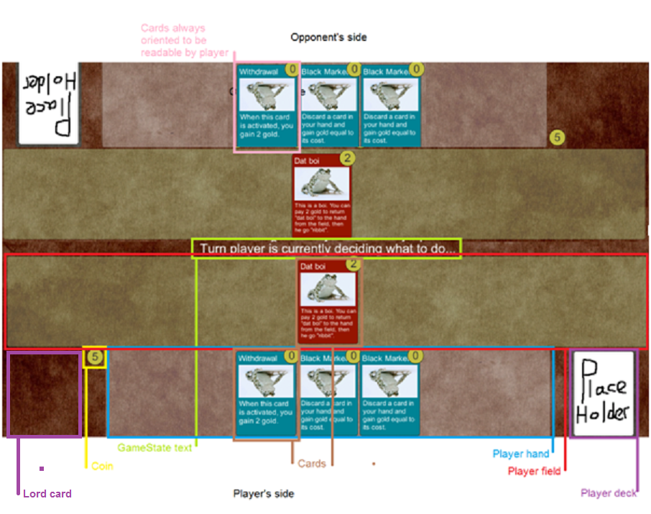

Player's drag cards from their hand to their field to play them using the mouse. Cards on field can be ordered to attack or use their effects by hovering the mouse over them, at which point buttons will appear to attack or use effect. Should the player need to target a card for attack or effect, that can be done by clicking the targeted card when required (indicated by the gamestate text).

### Discard pile/ deck searching interface

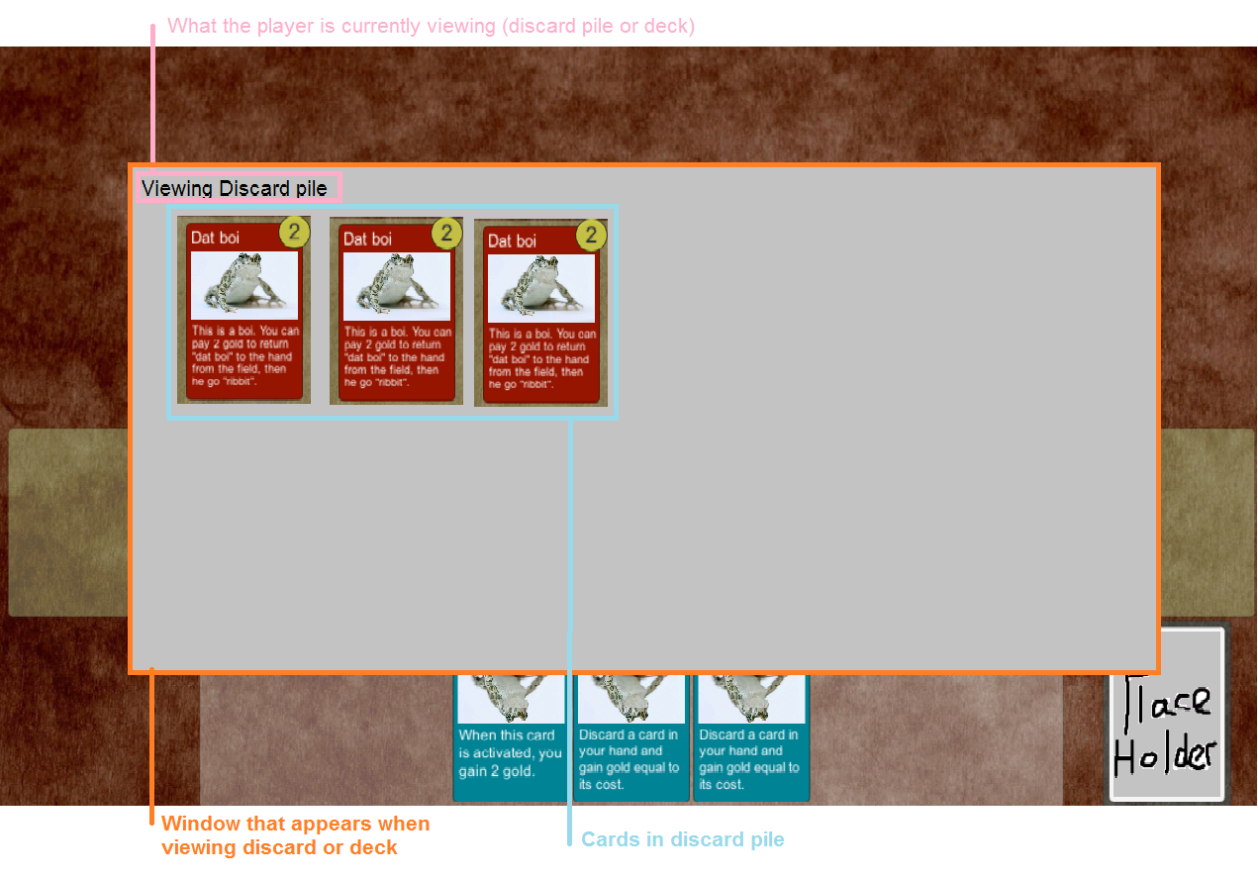

When viewing the discard pile or deck a window like the above appears. If viewing for the purpose of an effect the player may need to select a card in the discard or deck. In this case it can be selected by clicking on it.

### Card diagram

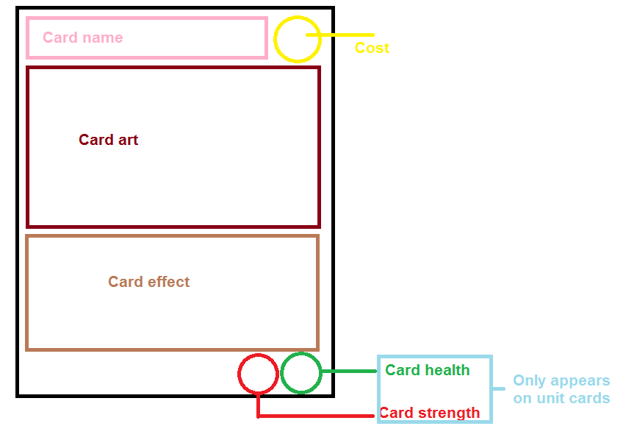

The above shows the layout of a card in *Cardgame,* showing where each component of a card is located

### Main Menu

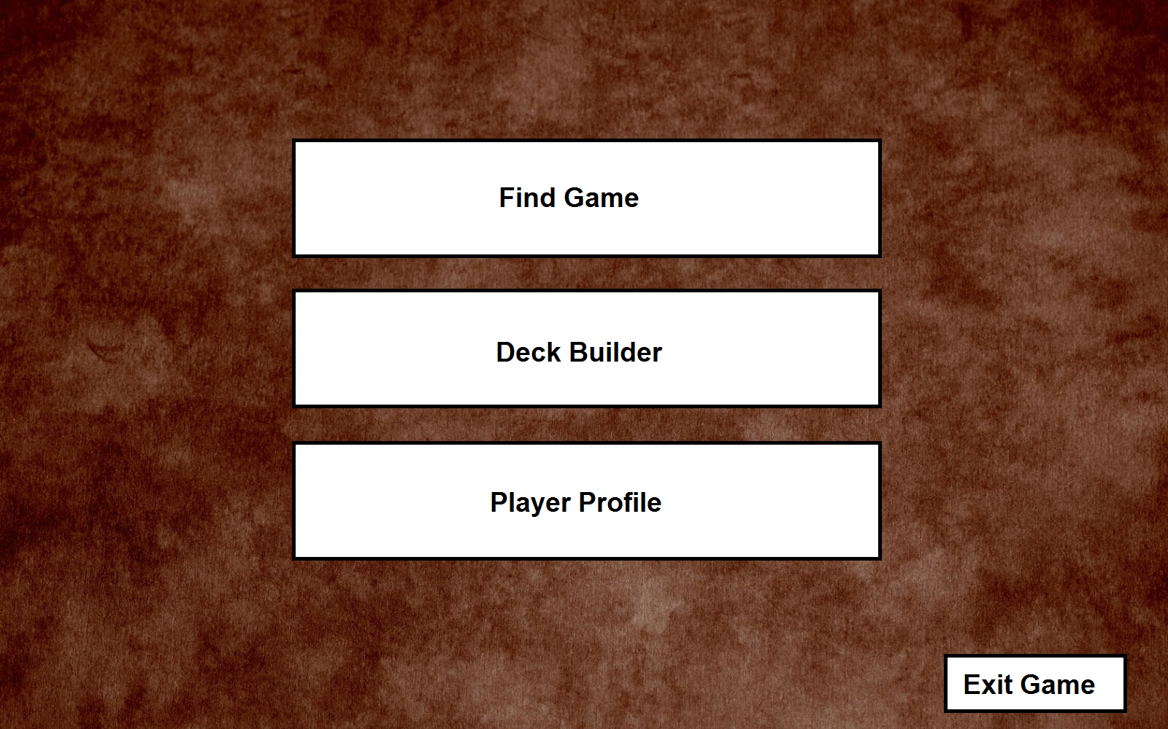

The Main Menu would have a layout similar to the above. Clicking the "Find Game" button will bring up a list of people in lobbies who are looking for someone to play with. On this page will also be a "Find Match" button which will automatch you with an available player with as close a Multiplayer score to you as possible.

The Deck Builder page will bring you into a page with a button for each of the decks you've built. Clicking one of those buttons will open up the Deck Editor for that deck, detailed in the "Deck Editor" section.

The player profile will open up your own player profile page, which will contain stats such as total wins, losses, multiplayer score, and potentially stats such as Favourite Leader/Unit/Utility based on usage.

Exit game would exit the game.

### Deck Editor

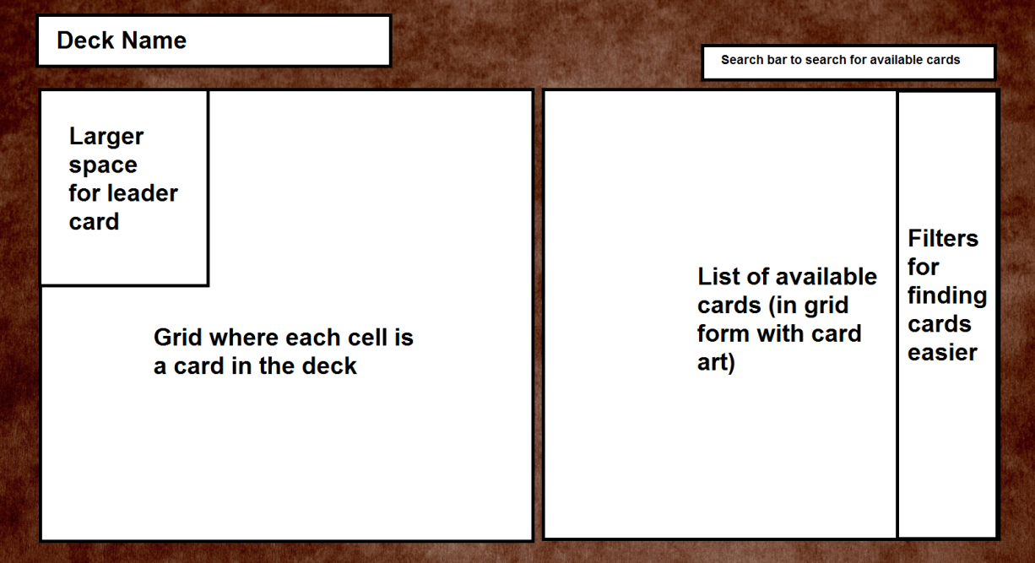

## Objectives

The objective of the game for both players is to drive their opponent to bankruptcy through raiding their gold stock, while also preventing the opponent from doing the same. Players achieve this through proper use of their cards, prioritising threats, maintaining card advantage, correct gold management and clever deck-building.

A player loses if they begin two turns with 0 gold. To keep track of how many turns they’ve begun in this state, they gain a debt counter at the beginning of their turn if they have no gold. This means a player can win when their opponent has 1 debt counter, and 0 gold at the beginning of their turn.